to send email follow this step:

1)

first login with your gmail account and go to this link-  <https://myaccount.google.com/security?utm_source=OGB&utm_medium=act#connectedapps>

and enable this checkbox

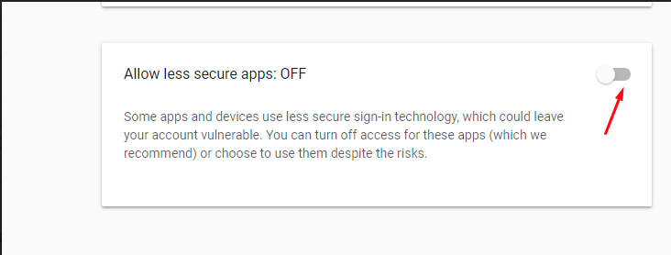

also go to this link-  <https://myaccount.google.com/u/1/lesssecureapps?pli=1&pageId=none>

and enable this checkbox

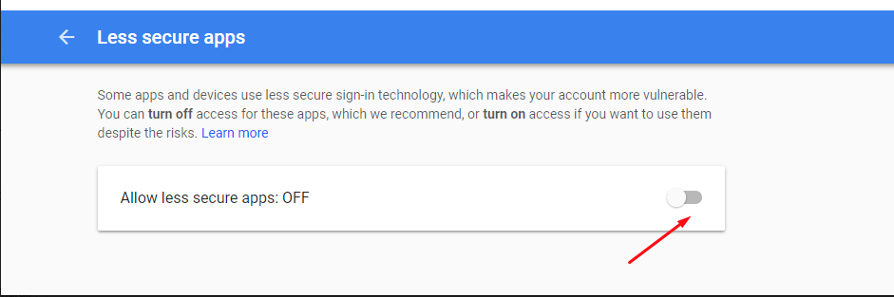

2)

go to Path: your_file_directory\ SmartOnlineTest\WEB-INF/email.properties and write your

email and password as in the below

email=dummy@example.com

password=123

Note: Do not write your email and password in quotes.

Where SmartOnlineTest is a project name.

And your_file_directory is netbeans / eclipse project location.

that's it hope this will help you.